**OBJECT ORIENTED PROGRAMMING**

**Lab Task 01**

**Submitted by: Waleeja Amjad – 247010**

**Submitted to: Sir Arslan Tariq**

**QUESTION # 01**

#include<iostream>

using namespace std;

//structure

struct student

{

int id;

char name[20];

char code[20];

char cname[20];

int marks;

};

int main()

{

// Number of students

const int num = 3;

// Array of students

student s[num];

int i;

cout << "Enter the details of students:" << endl;

for (i = 0; i < num; i++)

{

//data input from user

cout << "Enter the student id for student " << (i + 1) << ":" << endl;

cin >> s[i].id;

cout << "Enter the name of student " << (i + 1) << ":" << endl;

cin >> s[i].name;

cout << "Enter the course code for student " << (i + 1) << ":" << endl;

cin >> s[i].code;

cout << "Enter the name of course for student " << (i + 1) << ":" << endl;

cin >> s[i].cname;

cout << "Enter the marks for student " << (i + 1) << ":" << endl;

cin >> s[i].marks;

}

// Display data

cout << "\nEntered student details: \n";

for (i = 0; i < num; i++)

{

cout << "Student " << (i + 1) << ": \n";

cout << "Student ID: " << s[i].id << "\n";

cout << "Name of student: " << s[i].name << "\n";

cout << "Course Code is: " << s[i].code << "\n";

cout << "Name of Courese is : " << s[i].cname << "\n";

cout << "Marks obtained in that course are: " << s[i].marks << "\n";

}

return 0;

}

**OUTPUT**

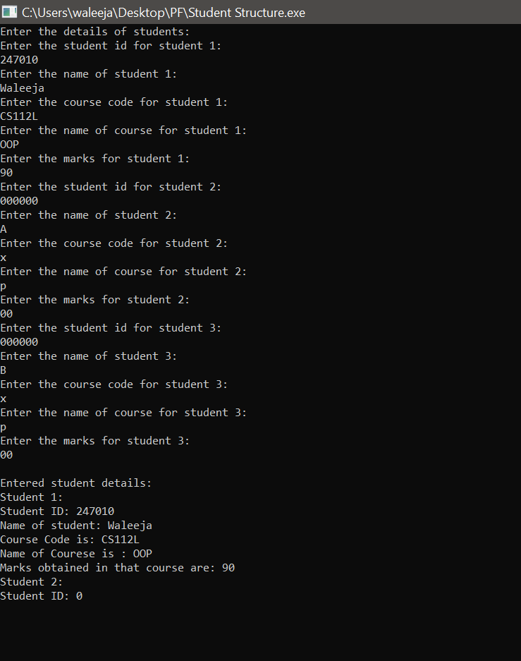

**QUESTION # O2**

#include<iostream>

using namespace std;

// Structure definition

struct employee

{

int employee_number;

float employee_compensation;

};

// Function declaration

void display_data(employee e[], int num);

// Main function

int main()

{

const int num = 3;

employee e[num];

int i;

cout << "Enter the data for three employees: \n" << endl;

for (i = 0; i < num; i++)

{

// Data input from user

cout << "Enter the employee number for employee " << (i + 1) << ":" << endl;

cin >> e[i].employee_number;

cout << "Enter the compensation for employee " << (i + 1) << ":" << endl;

cin >> e[i].employee_compensation;

}

// Call the function to display data

display_data(e, num);

return 0;

}

// Function definition to display data

void display_data(employee e[], int num)

{

cout << "Employee details:" << endl;

for (int i=0;i<num;i++)

{

// Displaying employee data

cout << "Employee Number: " << e[i].employee_number << endl;

cout << "Employee Compensation: " << e[i].employee_compensation << endl;

cout << "_________________________ " << endl;

}

}

**OUTPUT**

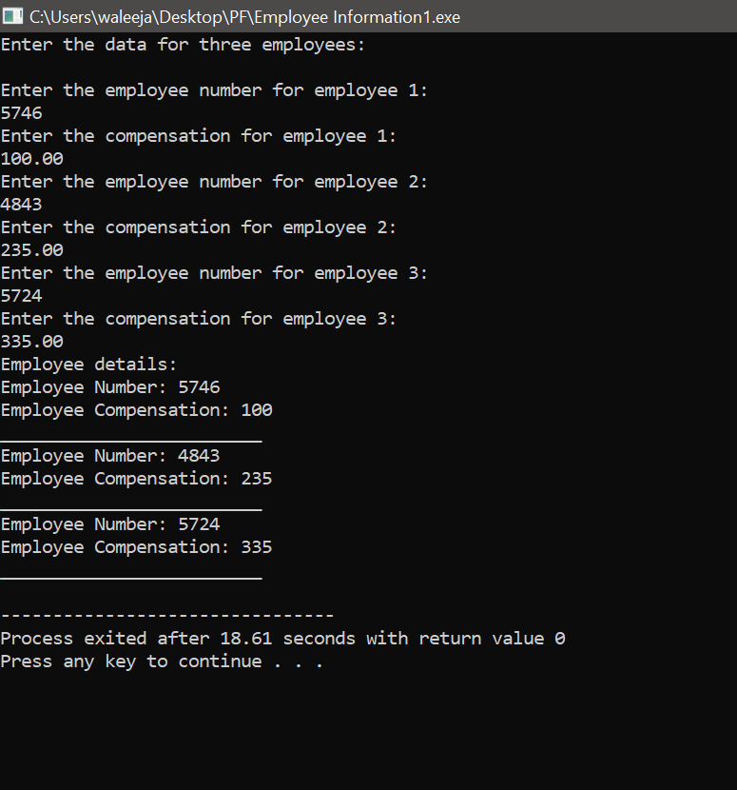

**QUESTION # 03**

#include<iostream>

using namespace std;

// Structure definition for a student

struct student

{

int id;

char name[20];

char code[20];

char cname[20];

int marks;

};

int main()

{

// Declare and initialize 3 student instances

student s1={247010,"Waleeja Amjad","CS112L","OOP",85};

student s2={247069,"Azka Asif","CS112L","OOP",80};

student s3={247021,"Amna Nadeem","CS112L","OOP",90};

// Calculate the total marks for all students

int tmarks=(s1.marks+s2.marks+s3.marks);

// Display the student details

//student 01

cout<<"Details of students:\n";

cout<<"Student 1:"<<endl;

cout<<"Student ID: "<<s1.id<<endl;

cout<<"Name: "<<s1.name<<endl;

cout<<"Course Code: "<<s1.code<<endl;

cout<<"Course Name: "<<s1.cname<<endl;

cout<<"Marks: "<<s1.marks<<endl;

cout<<"---------------"<<endl;

//student 02

cout<<"Student 2:"<<endl;

cout<<"Student ID: "<<s2.id<<endl;

cout<<"Name: "<<s2.name<<endl;

cout<<"Course Code: "<<s2.code<<endl;

cout<<"Course Name: "<<s2.cname<<endl;

cout<<"Marks: "<<s2.marks<<endl;

cout<<"----------------"<<endl;

//student 03

cout<<"Student 3:" <<endl;

cout<<"Student ID: "<<s3.id<<endl;

cout<<"Name: "<<s3.name<<endl;

cout<<"Course Code: "<<s3.code<<endl;

cout<<"Course Name: "<<s3.cname<<endl;

cout<<"Marks: "<<s3.marks<<endl;

cout<<"-----------------"<<endl;

// Display the total marks

cout<<"Total marks of all students:"<<tmarks<<endl;

return 0;

}

**OUTPUT**

